Assignment 4

**Create database**

Create or replace database demo_db;

**Create Schema**

create or replace schema demo_db.Assignment_4;

**create Info Table**

CREATE OR REPLACE TABLE demo_db.Assignment_4.info_table (

username varchar

,followers numeric

,country varchar

,joined date

,location varchar

,name varchar

,player_id varchar

,status varchar

,title varchar

);

**Create List Table**

CREATE or replace TABLE list_table(

username VARCHAR

,is_live boolean);

**Create Stats Table**

CREATE or replace TABLE stats_table(

last_blitz numeric

draw_blitz numeric

loss_blitz numeric

win_blitz: numeric

last_bullet numeric

draw_bullet numeric

loss_bullet numeric

win_bullet numeric

last_rapid numeric

draw_rapid numeric

loss_rapid numeric

win_rapid numeric

FIDE numeric );

**Create Stage**

CREATE OR REPLACE STAGE DEMO_DB.Assignment_4.MY_S3_STAGE

URL='s3://sami-s3-bucket/Data/'

CREDENTIALS=(AWS_KEY_ID='AKIA6XXXXXXXXBRN2' AWS_SECRET_KEY='4gYj4mT2FozwYwUDXXXXXXXXXX5iL1Tl5/6')

file_format = my_file_format;

list @DEMO_DB.Assignment_4.MY_S3_STAGE;

**Create pipe for Info Table**

CREATE OR REPLACE PIPE DEMO_DB.Assignment_4.info_table_pipe

AUTO_INGEST = TRUE AS

COPY INTO info_table(username, followers, country, joined, location, name, player_id, status, title)

FROM (

SELECT $1:username::varchar as username,

$1:followers::numeric as followers,

$1:country::varchar as country,

$1:joined::date as joined,

$1:location::varchar as location,

$1:name::varchar as name,

$1:player_id::varchar as player_id,

$1:status::varchar as status,

$1:title::varchar as title

FROM @DEMO_DB.Assignment_4.MY_S3_STAGE/Info_file.json

)

FILE_FORMAT = (FORMAT_NAME = 'DEMO_DB.PUBLIC.my_file_format')

ON_ERROR = 'CONTINUE';

alter pipe info_table_pipe refresh;

**create pipe for List Table**

CREATE OR REPLACE PIPE DEMO_DB.Assignment_4.list_table_pipe

AUTO_INGEST = TRUE AS

COPY INTO list_table(username,is_live)

FROM (

SELECT $1:username::varchar as username,

$1:is_live::boolean as is_live,

FROM @DEMO_DB.Assignment_4.MY_S3_STAGE/list_file.json

)

FILE_FORMAT = (FORMAT_NAME = 'DEMO_DB.PUBLIC.my_file_format')

ON_ERROR = 'CONTINUE';

alter pipe list_table_pipe refresh;

select * from list_table;

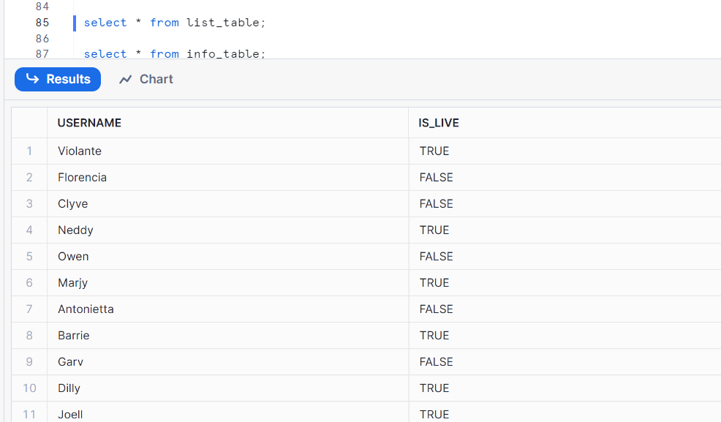

select * from info_table;

